**Full Stack Development with MERN**

**Project Documentation format**

**1. Introduction**

* **Project Title:** [Darshan Ease]
* **Team Members:** Sashidhar Reddy, Adhivk Sai, Yuva Sai Rithvik, Bharath A

**2. Project Overview**

* **Purpose:** To build a single website for different temples in india by which users can book the services in the temple and the temple representatives can add the services and donations
* **Features:** Booking sevices, Donations and announcements of different temples.

**3. Architecture**

* **Frontend:** We have the components folder by which we can have all the pages of the website. And app.js is to render the main application.
* **Backend:** We have models,controllers, routes which are all connected in the app.js file makes the backend.
* **Database:** we have different schemas namely admin, services, announcements, donations, templereps ,users.

**4. Setup Instructions**

* **Prerequisites:** Nodejs,expressjs,mongoDB,vite+react
* **Installation:**

1- Firstly navigate to frontend folder in the terminal and type npm install axios react-router-dom jspdf

2- and in the same folder run these two commands

1-npm install -D tailwindcss

2-npx tailwindcss init

3- And then navigate to the backend and run this command node express mongoose cors bcrypt

**5. Folder Structure**

* **Client and Server:**

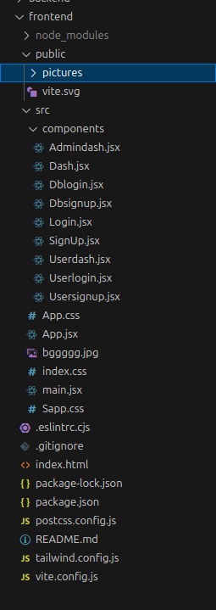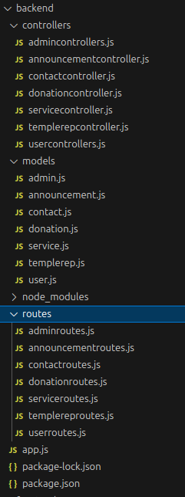

**6. Running the Application**

* + **Frontend:** npm run dev in the frontend directory
  + **Backend:** node app.js in the backend directory

**7. Authentication**

* The Authentication is done by the backend server using bcrypt which will encrypt the password entered by the user in the signup page.

**9. User Interface**

**Home Page:(Temple Representative Login)**

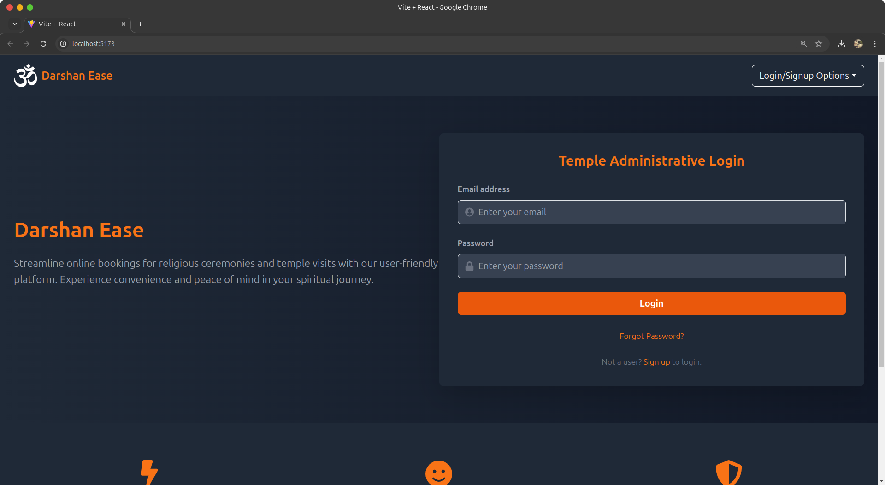

**Temple Representative Signup:**

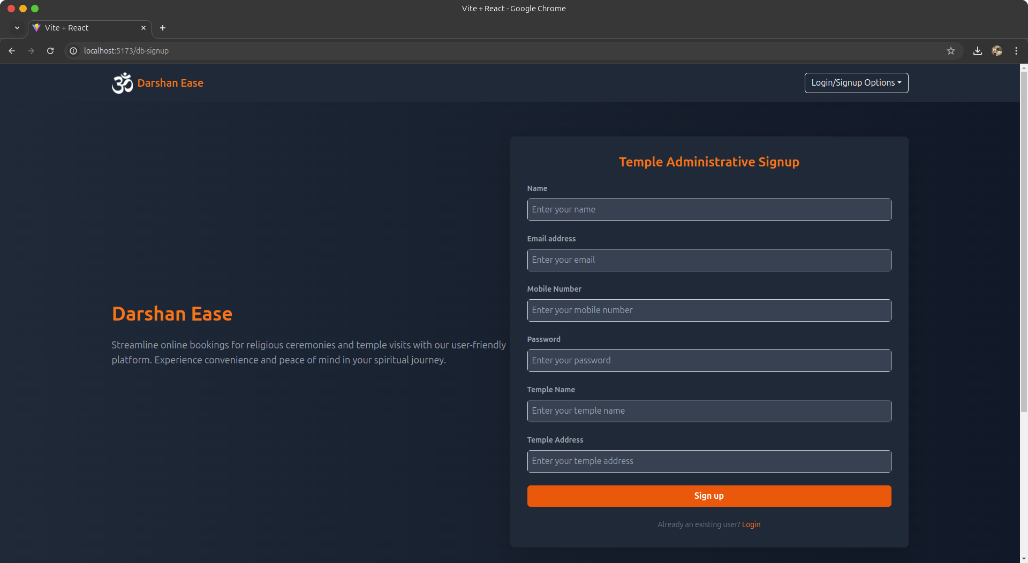

**User Login:**

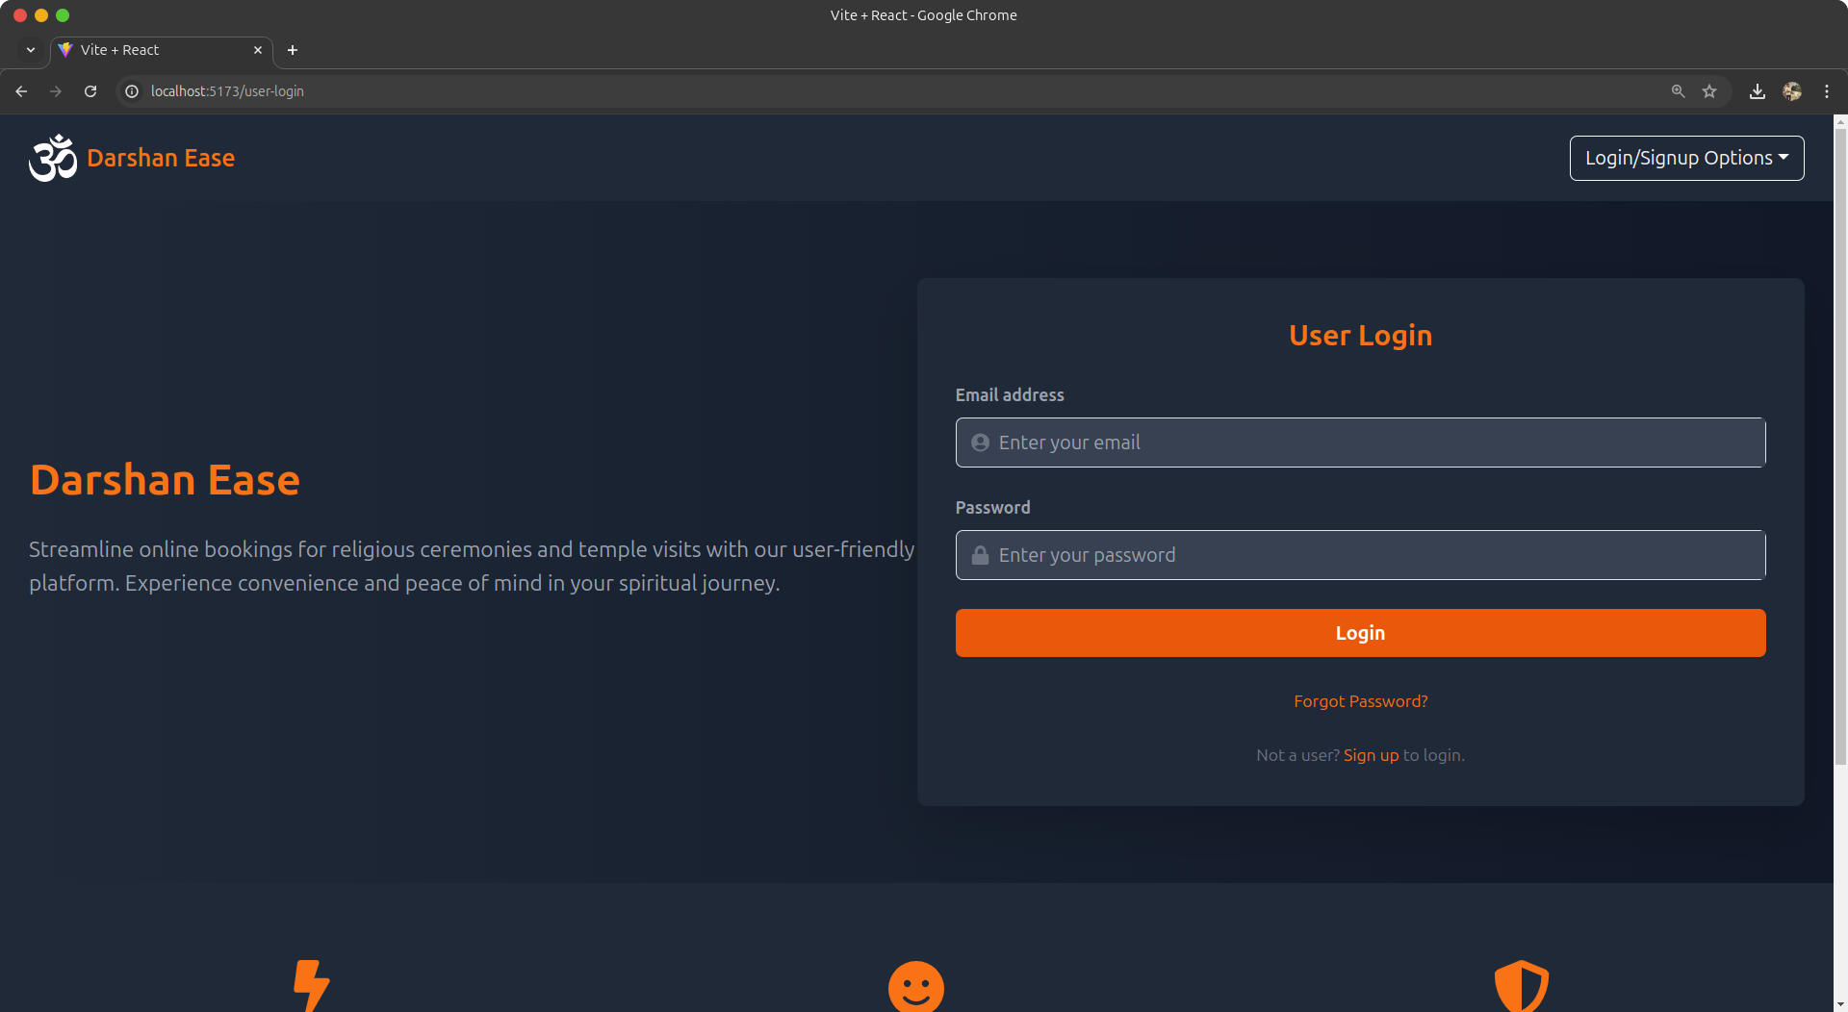

**User Signup:**

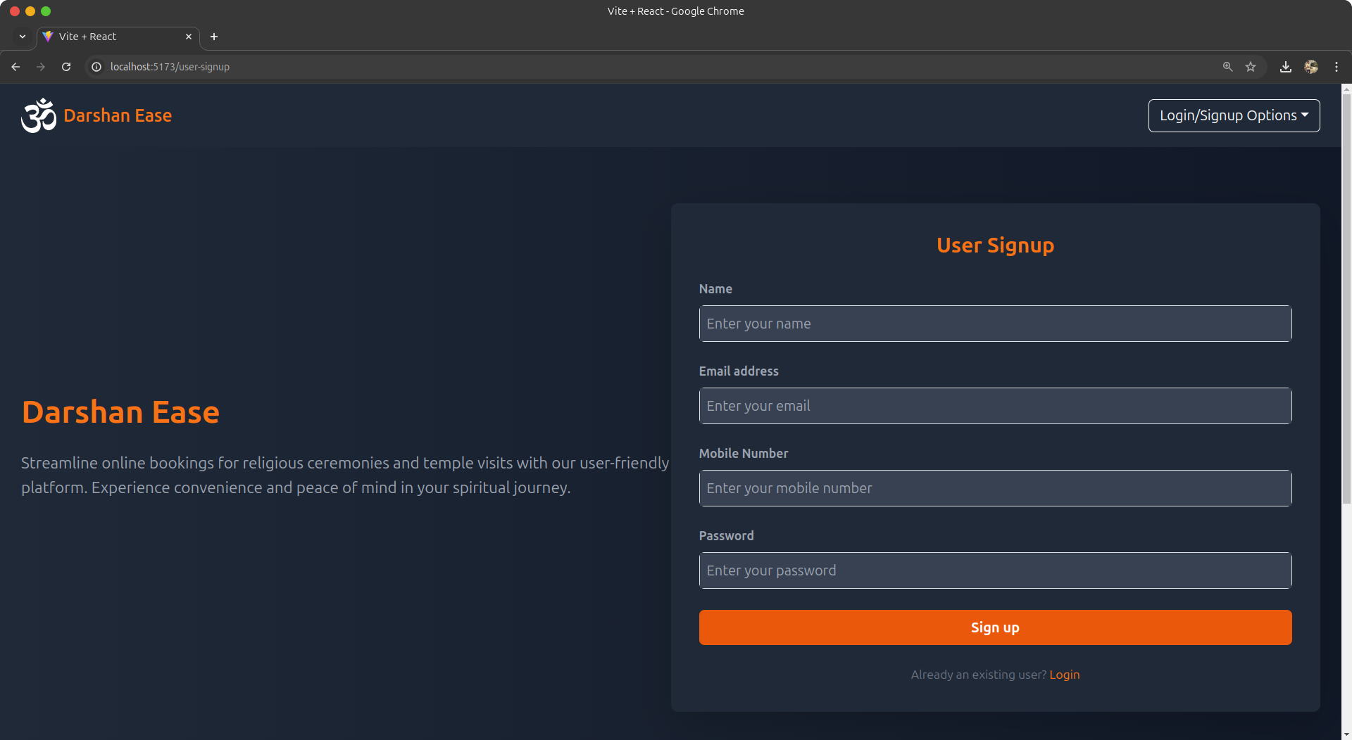

**Admin Login:**

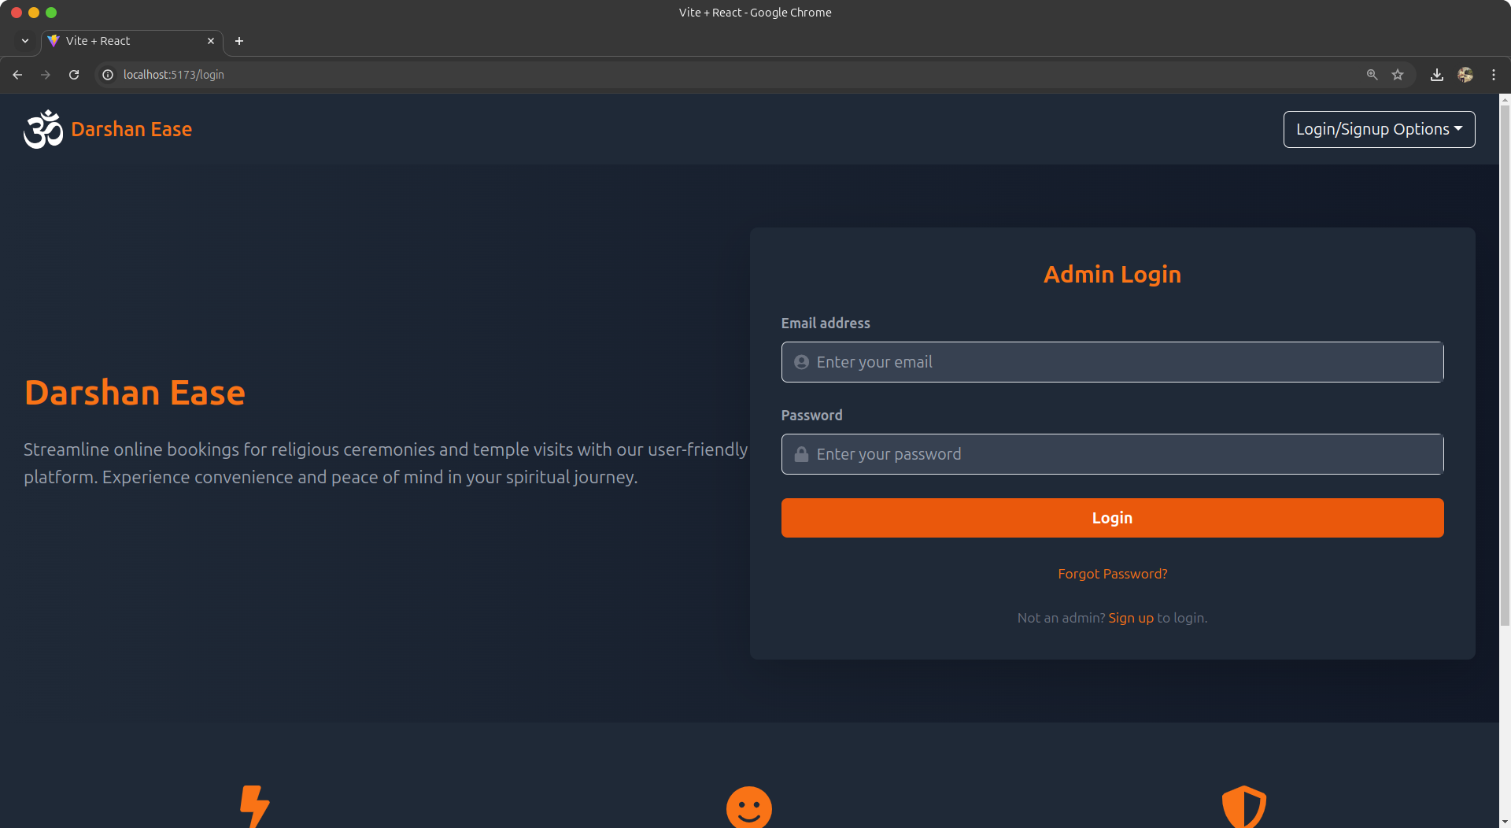

**Admin Signup:**

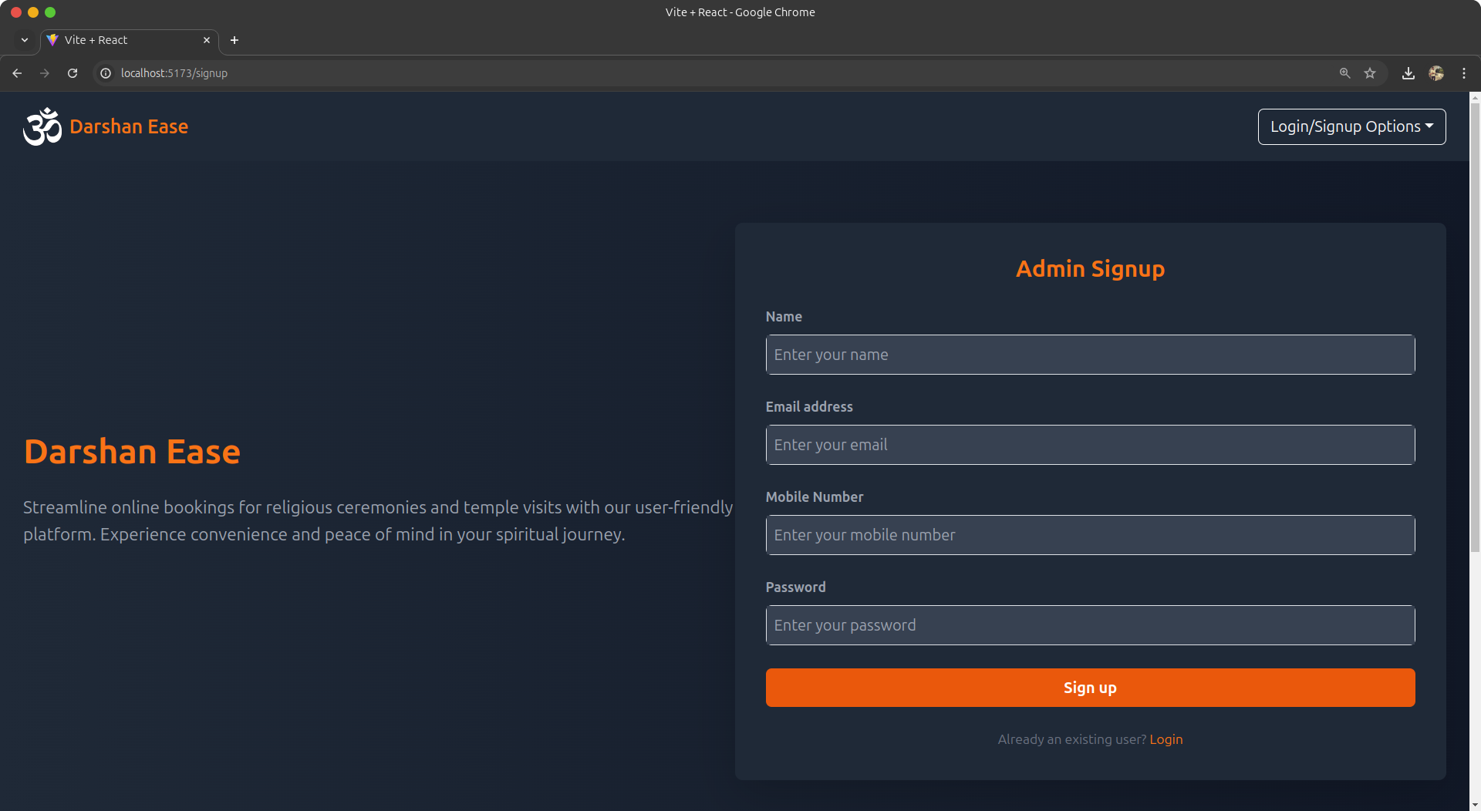

**Temple Representative Dash:**

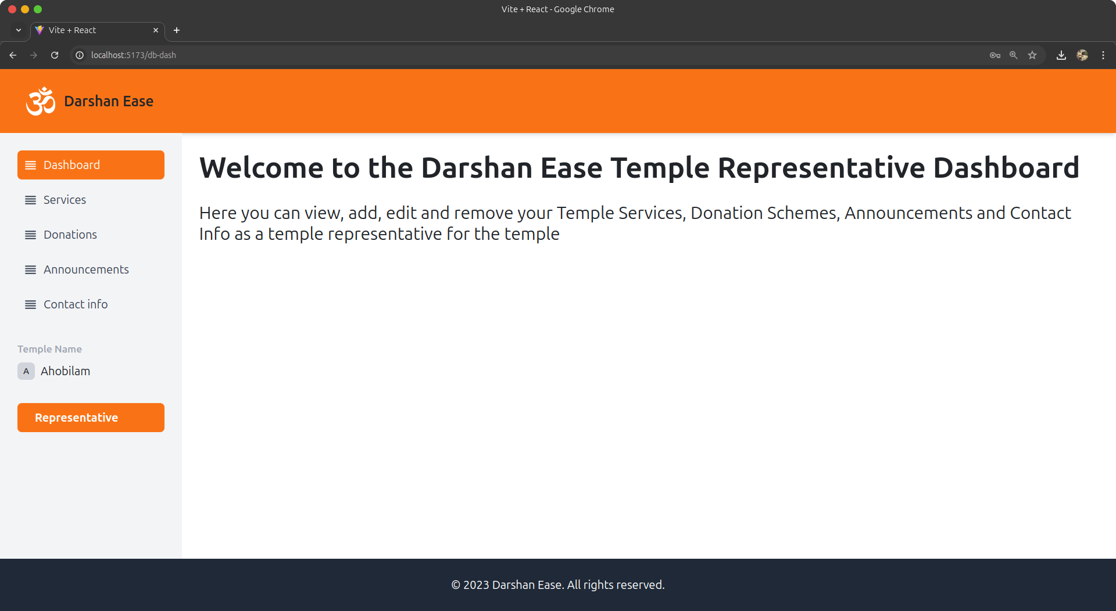

In this we can add services, donations and announcements and all by clicking in the side bar and we can logout

**User Dash:**

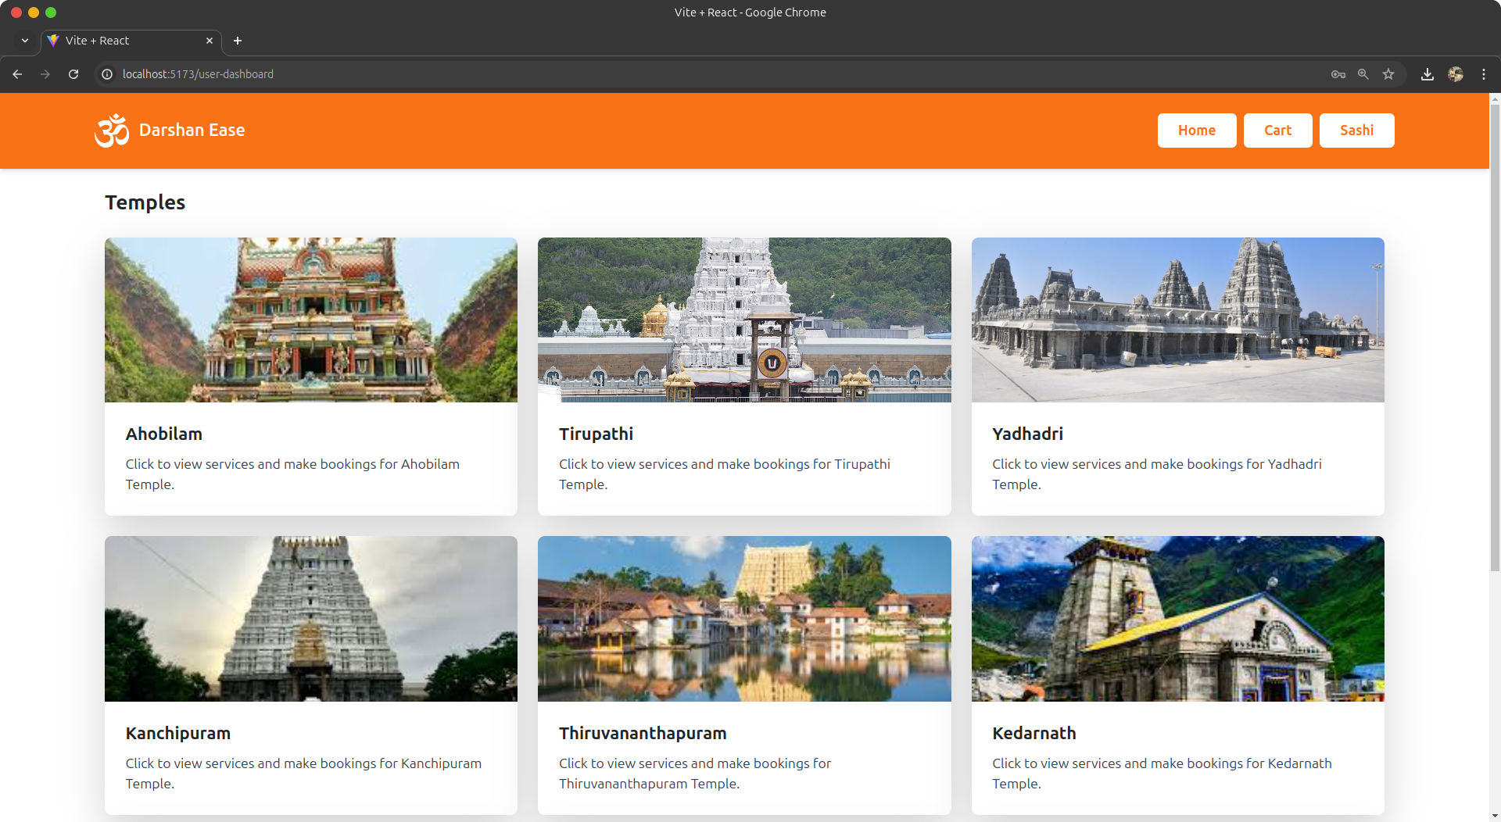

After clicking on the temple we can book services and add the donation by the cart and proceed to checkout.

**Admin Dash:**

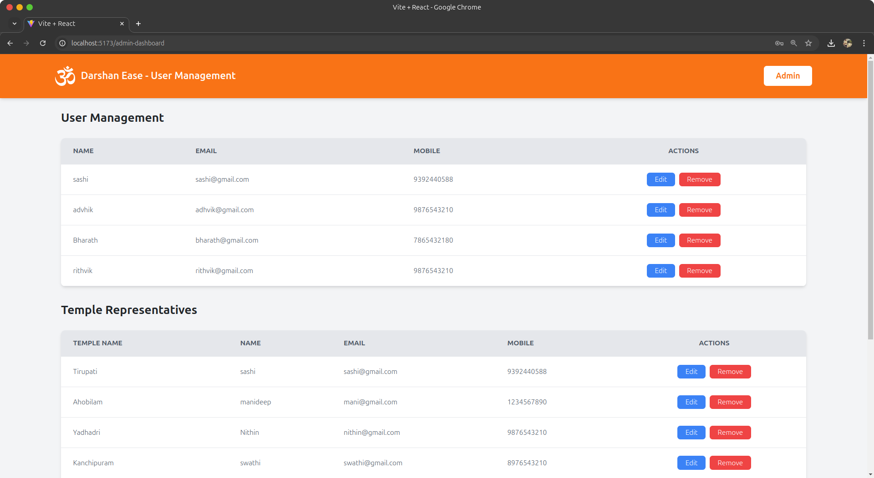

We can edit and remove the users and temple representatives from this admin dashboard.

**10. Testing**

We have tested our page manually by giving it to my college mates and used a inbuilt tool in chrome namely lighthouse.

**11. Screenshots or Demo**

* Provide screenshots or a link to a demo (if available) to showcase the application.

**12. Known Issues**

No known issues.

**13. Future Enhancements**

* By contacting to the temples we can make the project functional.